Payment Gateway

💳 What is a Payment Gateway?
# Source: Chatgpt (GPT‑5 Mini) at [12/18/2025]
A Payment Gateway is a technology service that securely authorizes and processes online payments between customers, merchants, and banks. It acts as the bridge between your website/app and the financial institutions (like credit card networks or banks).
✅ A Payment Gateway handles the transfer of payment information, checks for fraud, and ensures that funds move securely from the customer to the merchant.

🔄 How It Works (Step-by-Step)
# Source: Chatgpt (GPT‑5 Mini) at [12/18/2025]
- 🛍️ Customer places an order and enters payment details (card, wallet, etc.)
- 📡 Payment Gateway securely transmits the data to the acquiring bank
- 🏦 Bank/Processor contacts the card network (Visa, Mastercard, etc.)
- 🔐 Card network routes the request to the customer’s bank (issuing bank)
- ✅ Issuing bank approves or declines the transaction
- 🔄 Response goes back through the chain to the gateway and then to the website
- 💰 If approved, the merchant is paid later (settlement) by their bank

🛡️ Key Functions of a Payment Gateway
# Source: Chatgpt (GPT‑5 Mini) at [12/18/2025]
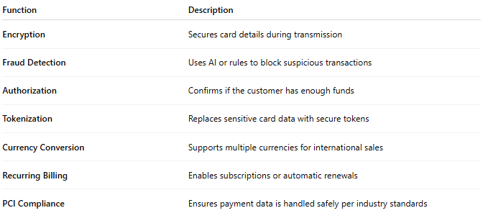

Function | Description
Encryption | Secures card details during transmission
Fraud Detection | Uses AI or rules to block suspicious transactions
Authorization | Confirms if the customer has enough funds
Tokenization | Replaces sensitive card data with secure tokens
Currency Conversion | Supports multiple currencies for international sales
Recurring Billing | Enables subscriptions or automatic renewals
PCI Compliance | Ensures payment data is handled safely per industry standards

🏪 Where It's Used
# Source: Chatgpt (GPT‑5 Mini) at [12/18/2025]
- E-commerce stores (e.g. Shopify, WooCommerce)
- Mobile apps (food delivery, ride-sharing)
- Online services (subscriptions, donations)
- POS systems in physical stores (with online integration)

🏷️ Popular Payment Gateways
# Source: Chatgpt (GPT‑5 Mini) at [12/18/2025]
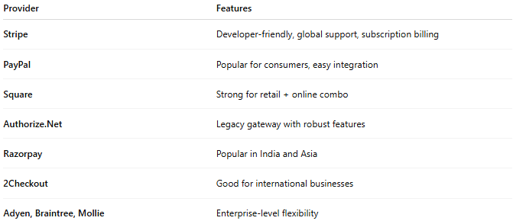

Provider | Features
Stripe | Developer-friendly, global support, subscription billing
PayPal | Popular for consumers, easy integration
Square | Strong for retail + online combo
Authorize.Net | Legacy gateway with robust features
Razorpay | Popular in India and Asia
2Checkout | Good for international businesses
Adyen, Braintree, Mollie | Enterprise-level flexibility

✅ Advantages
# Source: Chatgpt (GPT‑5 Mini) at [12/18/2025]
- ✅ Secure and fast payment processing
- ✅ Reduces risk of fraud and data leaks
- ✅ Supports multiple payment methods (cards, wallets, UPI, etc.)
- ✅ Helps businesses accept global payments
- ✅ Integrates with e-commerce and accounting systems

❌ Disadvantages
# Source: Chatgpt (GPT‑5 Mini) at [12/18/2025]
- ❌ Transaction fees apply (usually 2–3%)
- ❌ Can be affected by chargebacks and fraud
- ❌ Setup and compliance can be complex for new businesses
- ❌ May hold funds temporarily (especially for new merchants)

📌 Summary
# Source: Chatgpt (GPT‑5 Mini) at [12/18/2025]
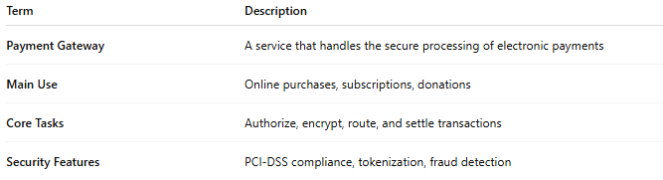

Term | Description
Payment Gateway | A service that handles the secure processing of electronic payments
Main Use | Online purchases, subscriptions, donations
Core Tasks | Authorize, encrypt, route, and settle transactions
Security Features | PCI-DSS compliance, tokenization, fraud detection

